

Mentee Application Form

# **FitT Mentoring Programme 2019**

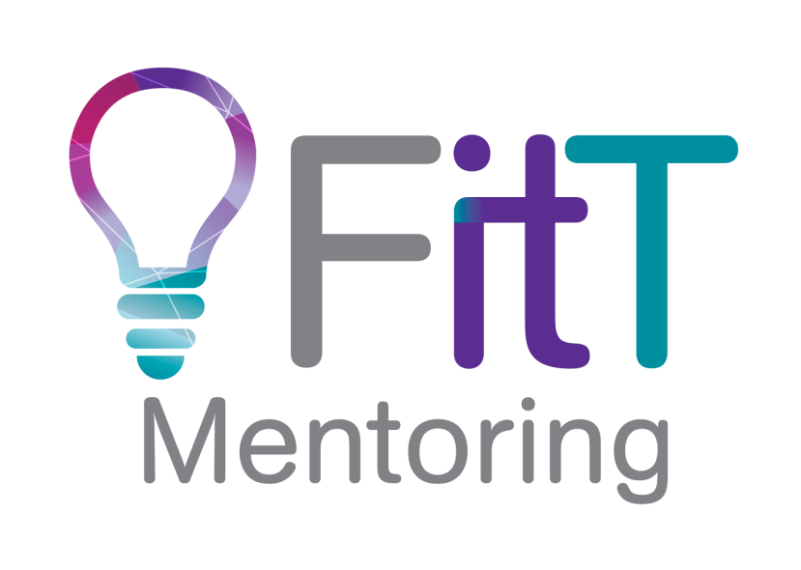

Complete this form in Word by clicking the fields in each box and entering your answer.

# **Personal Information**

First:

Last:

Preferred:

Job Title/ Role:

Company:

Contact Phone Nos:

Work:

Home:

Mobile:

### Email:

#### Work:

#### Personal:

#### Work Location (please be specific to suburb):

Home Location (full address):

### How will you pay your application fee? (Check one):

#### I will pay personally

#### My organisation will pay on receiving an invoice

#### My organisation is a FITT Corporate Member and I am one of its pre-paid nominees

If paying based on an invoice - the invoice should be sent to:

#### Name:

#### Email Address:

# **Selection Criteria**

1. Are you a member of FITT?

Yes  No  *Note, all 2018 Mentees will automatically become a member of FITT (no charge)

1. Have you participated in a mentoring programme before?

Yes  No  (If yes, please provide details)

Provide a short description here

1. How many years have you been working in ICT?

N.B: The target demographic for the mentees is between 1 & 15 years’ experience. If you have 16+ years’ experience, you may be asked to join a Mentoring Circle. This will be further discussed during the preselection interview

1. Briefly provide a summary of your career (you also need to submit an up-to-date resume)

Provide a brief description here

1. What are your career goals?

Within 12 months:

Provide your 12 month goals

Within 3 years:

Provide your 3 year goals

1. What do you think your current strengths are?

Provide your strengths

1. What do you think your current weaknesses are?

Provide your weaknesses

1. What development would you like to focus on for your mentoring programme?

Please select a maximum of 3 and prioritise them according to importance (1 = your top priority, 2 = second priority, 3 = third priority).

Understanding a career path for you

Changing career

Balancing work/life priorities

Motivating people

Strategic planning and management

Developing influencing skills

Navigating organisation politics

Business planning

Managing clients/customers

Organisational leadership

Other (Please specify)

1. What specifically are you hoping to gain from the mentoring programme (knowledge, skills, behaviours, benefits, experience)? Please be very specific. The more you can articulate your needs and objectives the better we are able to match you to a mentor!

Provide what you hope to gain here

# **Commitment**

Mentees who apply for a place must:

* Commit to a minimum of a *nine* month mentoring relationship with their mentor (via a mentoring contract), including monthly one-on-one meetings and undertake agreed actions
* Take ownership of arranging meetings, time, location, ensuring your mentors expectations are met
* Travel to meet Mentor for mentoring sessions
* Be prepared and open to receiving insight and feedback about yourself
* If you are accepted into the programme, you must pay the appropriate cost by the deadline date. Please note the date of your emailed application will decide whether you are eligible for the early-bird programme.
* ATTEND ALL MANDATORY SESSIONS.
* Conduct themselves in a professional manner at all times and not attempt to gain sponsorships, financial support, employment assistance or any other favour from the mentor for the duration of mentoring process.

Mentees who apply for a place are encouraged to:

* Volunteer to undertake at least one task or role for FITT during the year or the following year – please email your offer to mentoring@fitt.org.au.

# **Agreement and Signature**

### Data Privacy

By signing this application, I understand that my application and accompanying documentation will be shared by the FITT Mentoring committee and the volunteers involved in the various steps in the process.

I also understand and agree to share my email details with other mentees and mentors within the programme for the purpose of networking

### Refunds and Cancellations

* A full refund will be granted if cancellation occurs prior to notification of a successful match.
* There are no refunds of the fee (or any part of the fee) once the match is made.
* The cancellation policy applies even when FITT is unable to provide a mentor that meets your total satisfaction.

FITT will, however, attempt to provide a suitable match in the following session.

### Mentee Commitments and acceptance:

* I have read and am committed to the programme requirements
* I have read and agree to the refund and cancellation policy outlined above
* I understand that Mentors are volunteering their time to help me and I will do my best to respect their time and commitment.

Signed: (Please type name here – your email will be considered a signature for the purpose of this document) ______________________________________________________ Date:

Please ensure you have included your Resume with this application.

Submit this form (in WORD) with your resume by email to [mentoring@fitt.org.au](mailto:mentoring@fitt.org.au)